New application Extension application
UAS operator registration number
UAS operator name
ID code
Contact information:
Telephone
Email
Address
Date  DD/MM/YYY | Signature
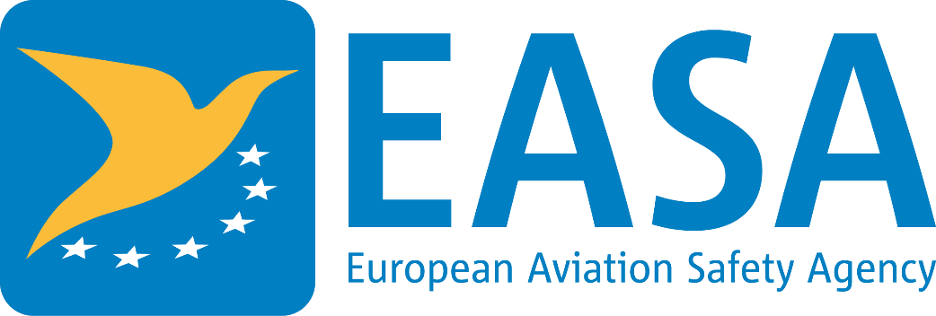 | Data protection: Personal data included in this application is processed by the competent authority pursuant to Regulation (EU) 2016/679 of the European Parliament and of the Council of 27 April 2016 on the protection of natural persons with regard to the processing of personal data and on the free movement of such data, and repealing Directive 95/46/EC (General Data Protection Regulation). Personal data will be processed for the purpose of the performance, management and follow-up of the application by the competent authority in accordance with Article 12 of Regulation (EU) 2019/947 of 24 May 2019 on the rules and procedures for the operation of unmanned aircraft.  If the applicant requires further information concerning the processing of their personal data or exercising their rights (e.g. to access or rectify any inaccurate or incomplete data), they should refer to the point of contact of their competent authority.  The applicant has the right to file a complaint regarding the processing of their personal data at any time to the national data protection supervisory authority.

